MINUTES OF JUDICIAL COMMITTEE MEETING VIA EMAIL ON 2 JULY 2020

Present:
House of Bishops  House of Clergy  Tikanga Māori | Bishop Steven Benford  The Rev’d Joel Rowse  Vacancy  Vacancy
Tikanga Pākehā | Judge Chris Harding  Judge Anne McAloon  Ms Brigit Brant
Tikanga Pasefika | Mr Walton Morgan  Ms Mele Taliai
General Secretary | Rev’d Michael Hughes

Appeal submitted by Mr Fia
The Committee agreed by email to approve the following actions and communications, which concluded this appeal process.

Following the serving of papers to all identified parties on 19 June 2020:
Bishop Ross’s query about serving hundreds of people within the groups he was served for/ and a response.
Mr Fia’s advice of two alternate contacts/ and the Secretary’s advice of a copy sent to them.
The reply from the Teachers Association advising they did not wish to submit a case.
Mr Fia’s withdrawal of the appeal.
A copy of the advice of that to all parties.
Bishop Bays response and attached Diocesan Statute.
The Secretary advising Mr Fia that all parties had been advised of the withdrawal and the matter was now closed.

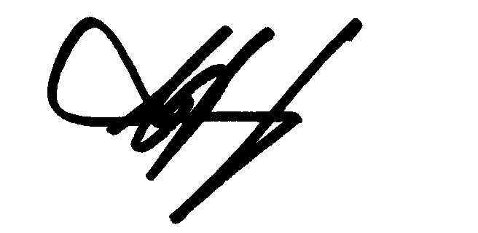
___________________
C J Harding
Chair
6 July 2020

